Ideation Phase

Define the Problem Statements

| Date | 27-06-2025 |
| --- | --- |
| Team ID | LTVIP2025TMID58018 |
| Project Name | Freelance Finder |
| Maximum Marks | 2 Marks |

# Customer Problem Statement Template

To define the core problems freelancers and clients face while using online job platforms, and use those insights to guide the development of Freelance Finder.

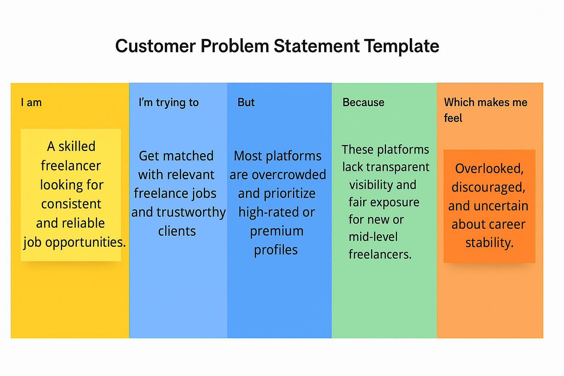

## Problem Statement (PS)

| PS No. | I am (Customer) | I’m trying to | But | Because | Which makes me feel |
| --- | --- | --- | --- | --- | --- |
| PS-1 | a skilled freelancer with limited visibility | find quality job postings that match my skills | most platforms are saturated or filter out my applications | they prioritize high-rated profiles or premium users | ignored and demotivated despite my talent |
| PS-2 | a small business owner looking for reliable help | hire trustworthy freelancers for short-term projects | I don’t know who to trust or how to evaluate credibility | platform reviews and portfolios can be misleading or inflated | overwhelmed and hesitant to outsource again |